**Section 24 done: 16/16 Bonus: Animations in React Apps**  
**Introduction**  
* We actually already do use some animations - some tiny animations - in our course project.  
* Think about this “ORDER NOW” button which bumps up when it becomes active. But we’re not doing much with animations and there would be some things we just couldn’t do or at least couldn’t do in a nice way.  
* So the overall goal of this module is to show you which different ways or options you have when it comes to animating React apps.  
* Because animations are important, they’re not just something to consider in apps, animations instead are something you might need in almost any app because animations guide user attention, they show the user what changed, they make it nicer to the eye and they are therefore an important concept.  
**Preparing the Demo Project**  
* We have a very simple project using create-react-app, we have a Backdrop, a Modal and this List component   
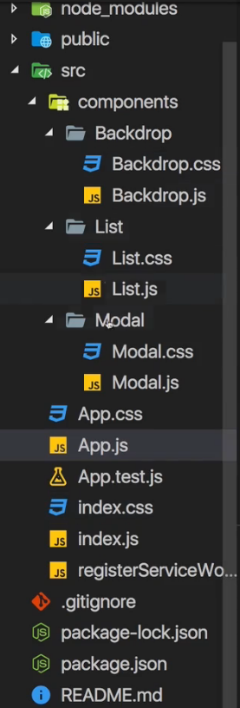 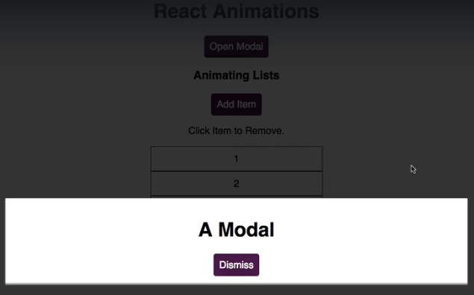  
* The Modal is always there so we’ll need to add some functionality to show it or hide it.  
* We can remove items by clicking on them, add them by using the “Add Item” button.  
* The idea of course is to animate both the appearance and dismissal of the Modal as well as our List of list items.  
* Let’s dive into the different options we have for that.  
* But before we actually start, let’s make sure that we have a way of showing and hiding the Modal.  
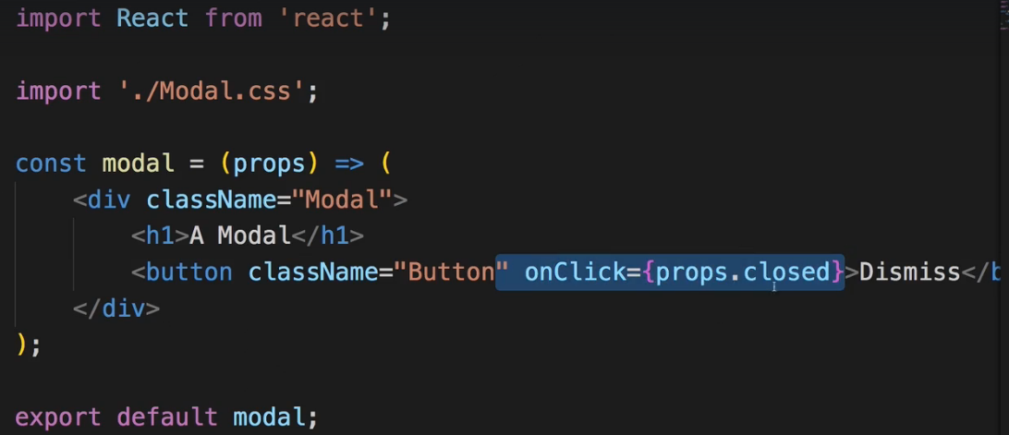  
* Now let’s say I want to control whether the Modal is displayed or not, inside this Modal.js file for now by simply showing or hiding the Modal.  
* We can do this by going to the Modal.css file.  
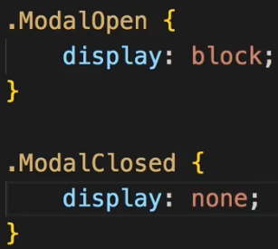 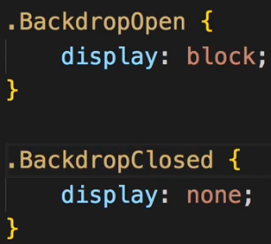  
* And let’s do the same for the Backdrop.  
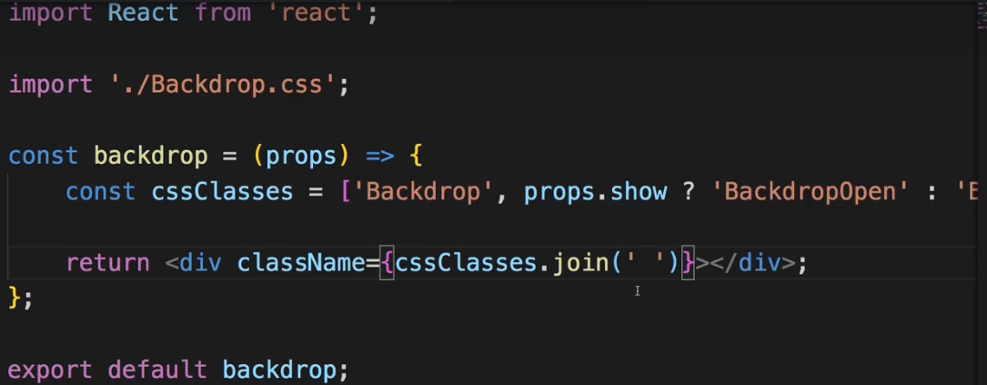

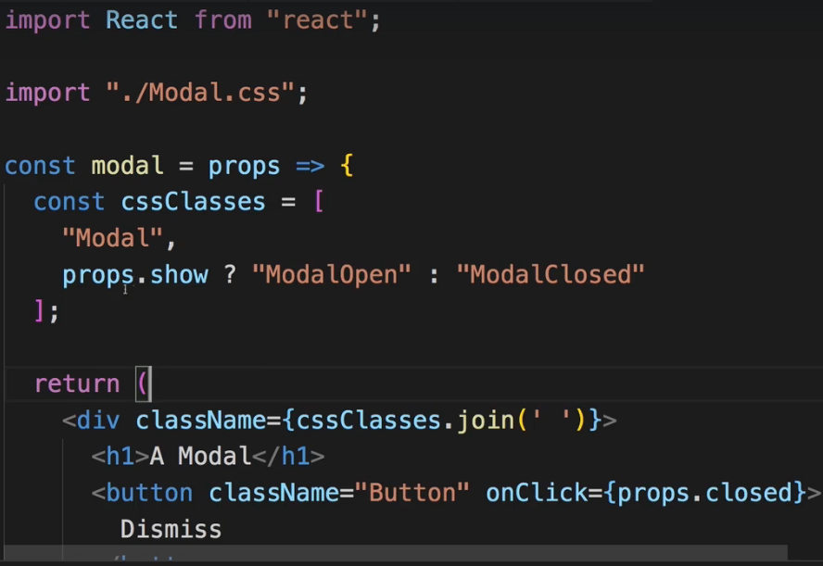  
* Now let’s just pass that prop to them.  
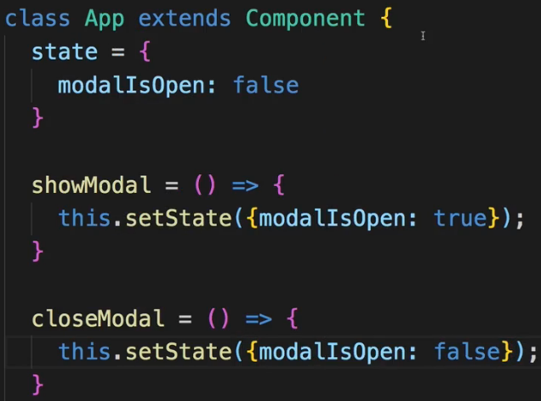  
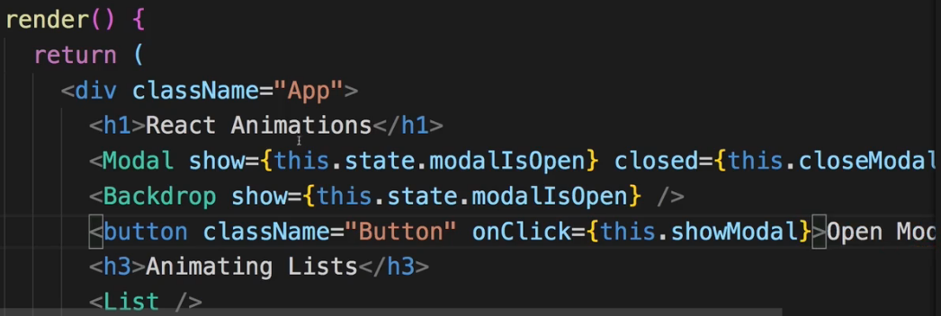  
* Now the showing/hiding works.  
**Using CSS Transitions**  
* In general when working with animations in React apps, we got multiple ways of doing that.  
=> The easiest and straightforward way is a way which has nothing to do with React - using CSS Transitions and Animations.  
* Let’s say we want to have the Modal fly in from the top and also change the opacity. And do the same when we close it.  
* translateY(0) basically says: use the position it should have by the way we positioned it in our HTML code, the default position in this case.  
* translateY(-100%) to move it up by 100%.  
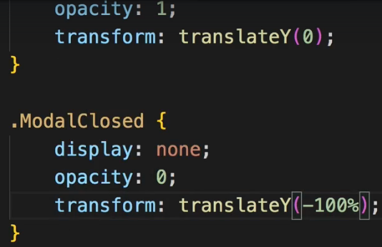  
* Now if we try it, we see no difference.  
=> Let’s add a transition property to the .Modal. This is a default CSS property which allows us to specify some CSS properties which should not be applied instantly but instead be animated over time. If we use transition: all, then no matter which property we change, we want to animate this.  
* With ease-out you start faster then you end.  
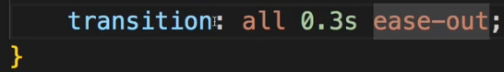  
* If we now try it, we still see the same as before.  
=> The reason for this is that we also changed display. Display block/none, this basically prevents any animation from happening with transition because CSS doesn’t recognize that it makes sense to animate it because to CSS it’s hidden anyways by default and then it’s instantly shown, so why animate anything inbetween, it would’ve been hidden until the animation ended anyways.  
=> And the display property can’t be transitioned.  
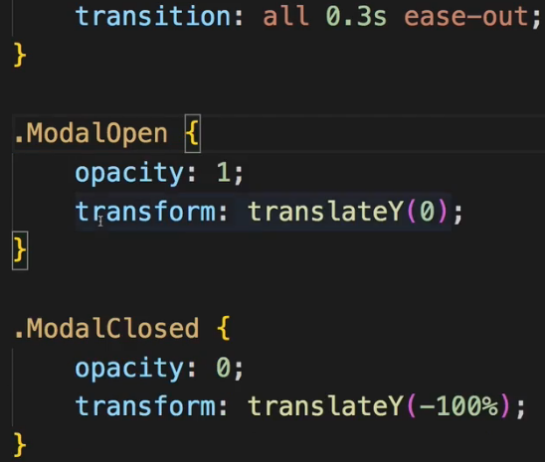  
* Now if we click the “Open Modal”, it slides in, if I dismiss it, it slides out.  
* The reason for this effect is that by default the Modal now has this opacity of 0 since the .ModalClosed class is attached if the `show` property is false and it is false as long as we haven’t clicked the “Open Modal” button.  
* Here’s 1 important takeaway: animating it like this is perfectly fine and for this kind of animation, that might be the best possible solution even, because you’re using native CSS features which tend to be quite well-performing and if you don’t need more control than that, you got all you need here. We got an animation for opening and closing the Modal. So CSS Transitions are a fine way of animating a lot of things in CSS.   
* And actually we’re also using a CSS Transition in our course project for the Modal.  
* Still, I want to dive into some other options and also limitations of CSS Transitions.  
**Using CSS Animations**  
* CSS Animation also has nothing to do with React.  
* It simply allows you to define a bit of more complex and controlled animation than with the transition property because with the transition property we’re just saying: Hey, whenever X property changes, animate that change and figure out how to animate on your own basically.  
* Now a CSS Animation is a set of steps you want to execute, described in detail.  
* For that you create so called **keyframes**. Here you can define the steps, so inside the animation in percentages % or just with `from` and `to` if you only 2. The start is 0%, then end is 100%.  
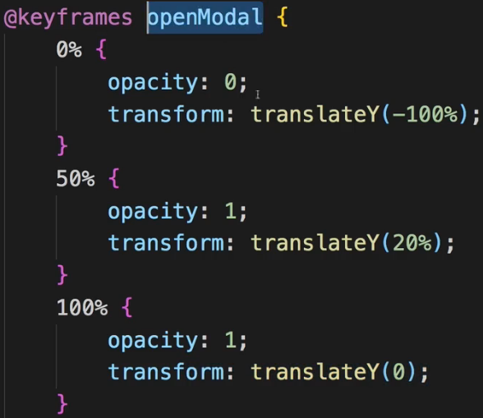  
* Now we can use this in .ModalOpen class because this is the class which gets attached when the Modal should be shown.  
* `**animation**` is a special property which allows us to define a set of keyframes which should be executed whenever this CSS class is present on an element and that of course includes when it is added to the element.  
* If we don’t define anything after the ease-out, it would jump back to the starting state once the animation played through, if we wanna keep the final state, so the 100%, we need to add the `**forwards**` value here.  
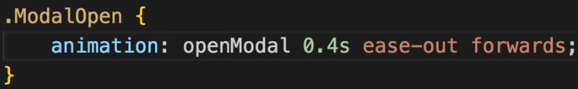  
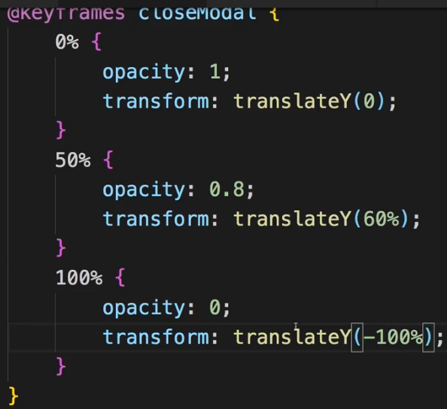  
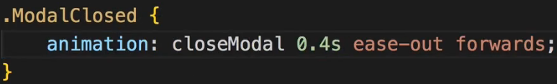  
* This gives us more control and in many cases CSS Animations give us all we need to achieve certain animations or looks.  
**CSS Transition & Animations Limitations**  
* Now what’s 1 limitation of using these animations though?  
=> We can see it if we use the chrome dev tools to inspect our DOM. We see that our Modal DIV and our Backdrop DIV are always present, they’re just not visible because we’re actually animating this.  
=> That of course means that all our HTML code is always in the DOM and just not displayed because the opacity is 0. This might not be what we want, it populates our DOM with a lot of elements, which slows it down a little bit and which also might not be the best case or the best way to do for accessibility and it is not very React-ish if we in the end are back to having to control the display of things with just CSS. It’s also not super bad, we do it like this in our Burger Builder in the end, and especially for this Modal, or some SideDrawer menu, this might be perfectly fine.   
* But let’s say we really want to not show/hide this by passing the `show` prop but instead by using our `modalIsOpen` state to really show or hide the Backdrop and Modal elements.  
* I can of course do this by using a ternary expression.  
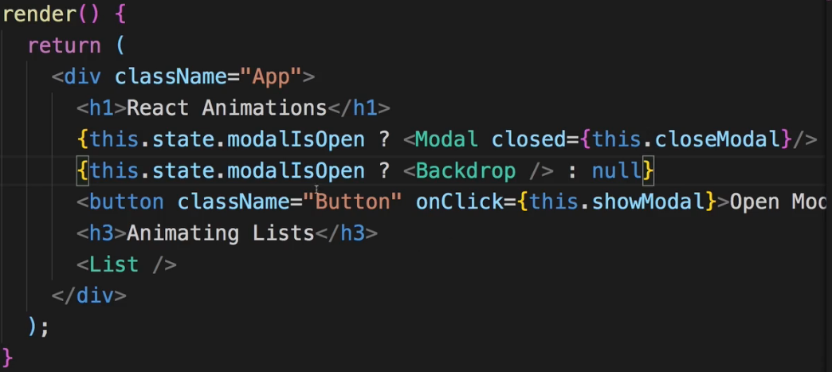  
* Now we don’t see the moving out animation, the reason for that is that React doesn’t wait before re-rendering this JSX and therefore removing the Modal and Backdrop when the state changes - for our animation to finish because it’s not aware of that animation and it’s good that it doesn’t scan our elements which are to be removed for possibly running CSS animations, that would be a performance nightmare.  
* So here we now see a limitation we have with CSS Animations and Transitions: Animating IN - showing it - did actually still work because adding the element, the Modal, simply now also adds the CSS class and the animation therefore plays. But removing happens instantly and that of course means that we get a kind of a bad behavior/look here.  
* Now for that, we need other tools to manage this.  
**Using ReactTransitionGroup**  
* You can google for react-transition-group to find its GitHub Repository.  
* This package allows you to smoothly animate elements when they are added to the DOM or removed from the DOM.  
**npm install --save react-transition-group**  
* Let’s first try to animate a button. This button should simply show/hide a DIV with a background color.  
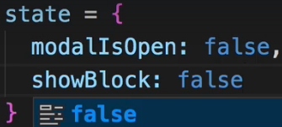  
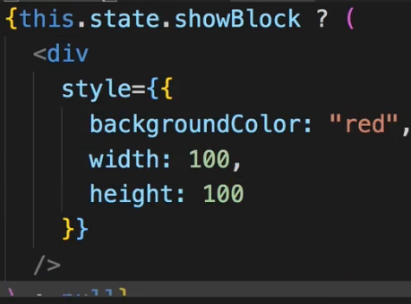 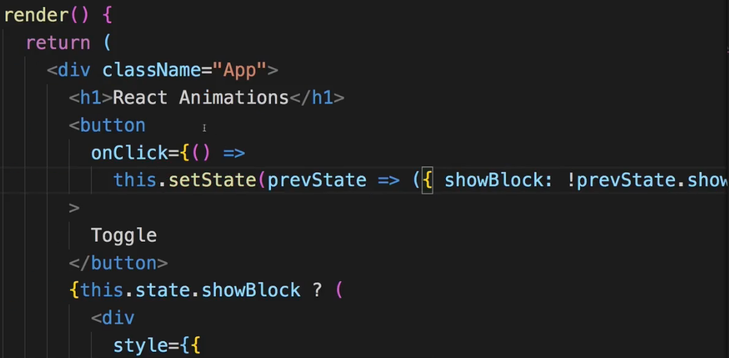  
* **Transition** component.  
  
=> We use this Transition component to wrap what we want to animate.  
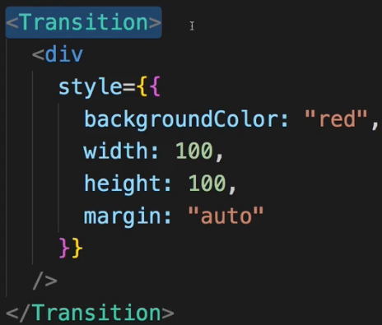  
=> That alone won’t do much but we can now use this Transition component to control the display of elements inside of it and especially the animation of these elements.  
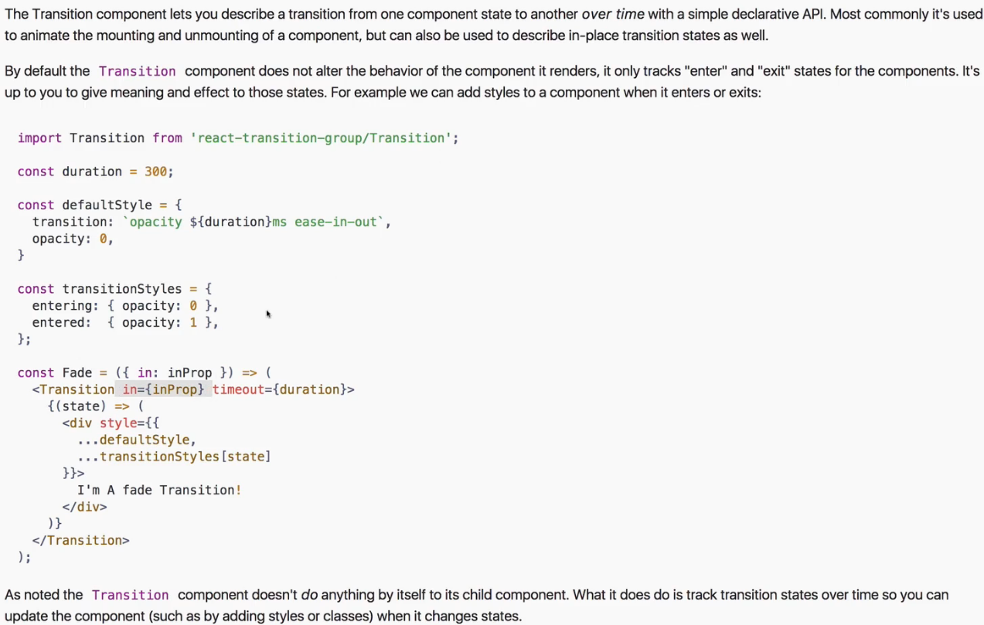  
* **in** property - this decides whether the elements wrapped inside the Transition component should be shown or not. And the Transition component manages 4 internal states:   
ENTERING, ENTERED, EXITING, EXITED  
which we can listen to to decide how our element should be shown.  
* **timeout** determines how long this animation should be played. In other words how long it takes to switch from ENTERING to ENTERED and from EXITING to EXITED. And it’s this inbetween thing you can then animate.  
* Inside this Transition component we should render a function. That’s what the Transition component in the end gives us back - a value we can use in a function - the state.  
=> So in the simplest form what we can simply write a function, that’s why we need {}, this function should then return the JSX that we want to actually render.  
* Let’s try this simple example:  
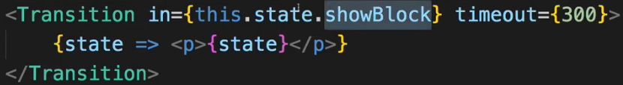  
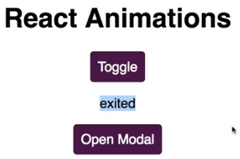  
=> We see “exited” there because I’m just outputting some text here with my paragraph where I output the `state` value, which is given to us by this Transition component.  
=> If I click “Toggle”, it changes first to “entering” and then to “entered”.  
=> If I click “Toggle” again, it changes first to “exiting” and then to “exited”.  
=> How long the switching takes depends on the `timeout`.  
* That’s all this Transition component does for you - it manages this `state` argument it gives to you in a function you pass as a child of the Transition component and this managed `state` property takes your timing into account.  
* We can now take advantage of the states to manipulate our style depending on the `state`.  
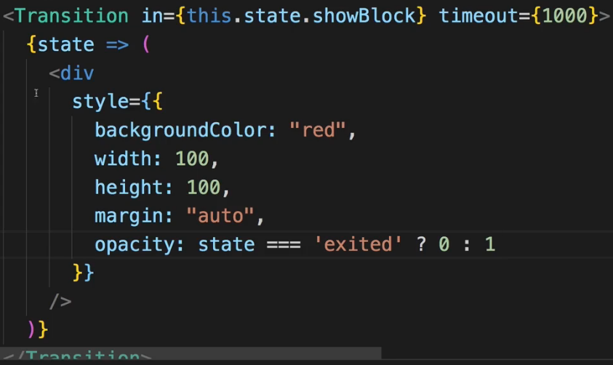  
* Now to add an animation, we just needd to tweak this a little bit.  
=> We have to add the `transition` property.  
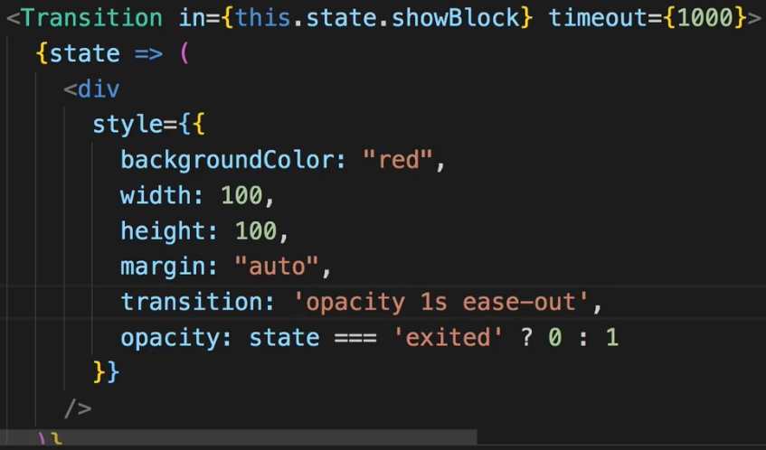  
* Now it’s animated in and animated out.  
* Now we got 1 important thing - we’re controlling this animation with the Transition.  
* It’s still always in the DOM though, but we can control this by adding more props to the Transition component.  
=> We can add `**mountOnEnter**` which is a boolean prop which says: yeah, if the `in` property is set to true, you should add the wrapped element to the DOM.  
=> On the other hand you can add `**unmountOnExit**` to really remove it from the DOM if `in` is false.  
=> No animation right now due to the way we’re controlling this - we’re only changing the opacity here when the state is EXITED, which is too late.  
=> If we set it to EXITING, now you see it fades out.  
* So now for removing it, we’re taking advantage of these 2 states for removing the element: EXITING and EXITED. Now it’s not removed from the DOM until the entire animation (timeout) is over.  
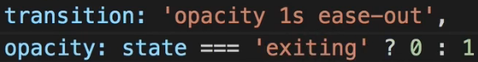  
* And now we really tell React to only remove this element after the given timeout with the help of this Transition component.  
**Using the Transition Component**  
* Let’s now use it on Modal to animate it.  
* I will leave the check for the Backdrop because I want to still show/hide the Backdrop just like this, without an animation. Therefore I can just show like this to true always because it’s removed anyways if I don’t want to show it.  
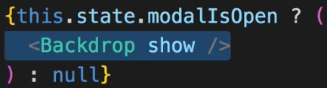  
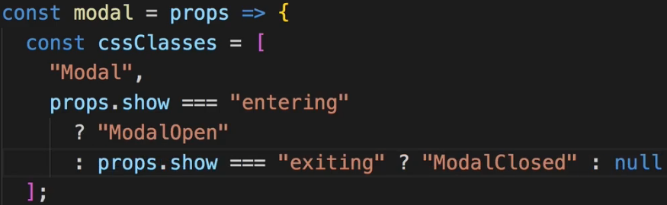  
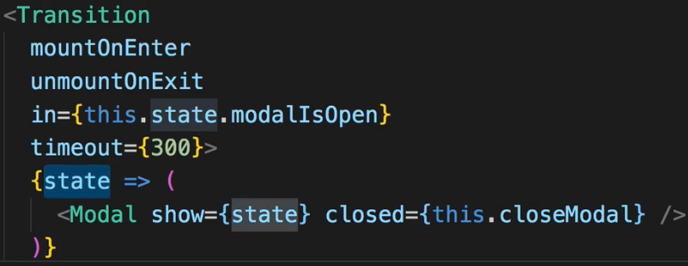  
**Wrapping the Transition Component**  
* 1 important thing to know is that you can also nest this inside any component you want.  
* We can wrap our Modal.js return in it if we import it of course:  
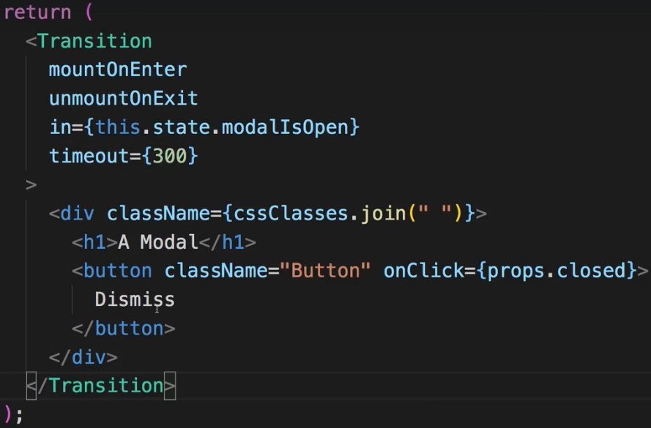

* Now make Modal always present in our App.js component.  
  
* Now we have to adjust our code a bit.  
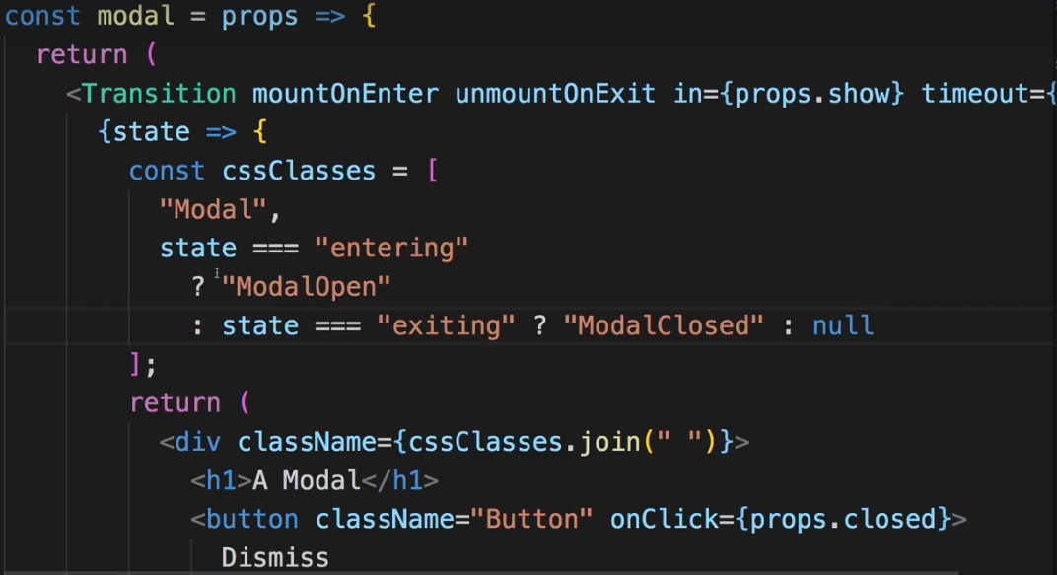  
* So the same logic as before but now inside the Modal.js.  
**Animation Timings**  
* Now we have a timeout of 300ms, but the animation we play, takes 0.4s.  
* Now that isn’t an issue, it simply won’t play the entire animation, that’s the thing.   
* Which then of course might be an issue again.  
* The `timeout` you set on the Transition component determines how long the ENTERING and EXITING state for which we’re checking, will be held, for how long this is basically the state it uses.  
* If you define a `timeout` which is much shorter than the animation you play, you simply quit the animation preemtively because you switch the state too early.  
* 1 other thing you might want to configure in some cases is the `timeout`.  
=> The `timeout` right now is only our value in ms, defined as a number.  
=> What if you wanted different timings for ENTERING and EXITING though?  
=> Let’s set it up outside the component, under imports.  
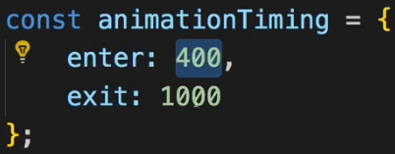  
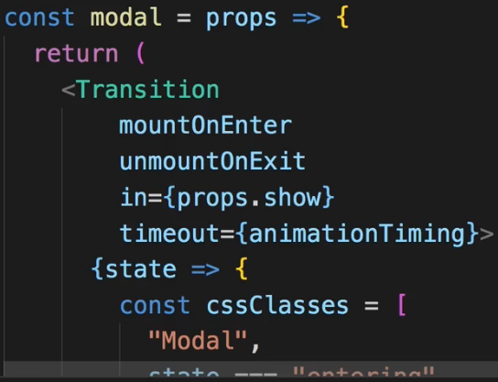  
**Transition Events**  
* Sometimes you want to execute a certain code when the state of the animation finishes and not just change what you render to the screen.  
=> For that you get various callbacks, you can add, functions, you can execute, to a Transition.  
* Let’s use this on the red DIV we were playing with.  
* We have 6 different events: **onEnter**, **onEntering**, **onEntered**, **onExit**, **onExiting**, **onExited**.  
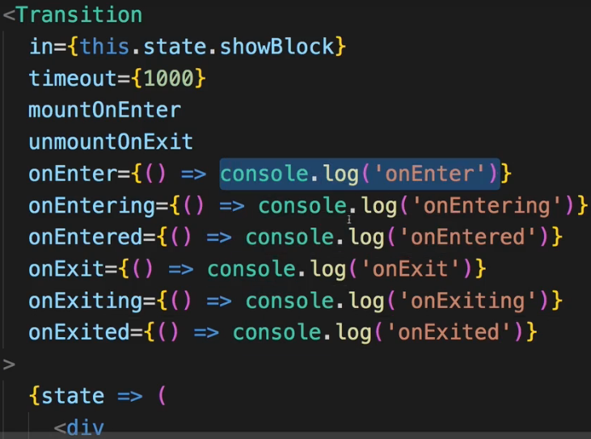  
* You can run any code you want.  
* They execute in this order.  
* onEnter is executed right before we enter the ENTERING mode, onEntering is then executed once we entered the ENTERING mode and onEntered is executed once we entered the ENTERED mode.  
* The EXITING works the same way.  
* This can be nice to create staggered animations, where you want to wait for 1 animation to finish before you start the next one.  
* With these methods you got all the control you need to find out what happened, what finished, what started, and then time your other animations based on that for example.  
**The CSSTransition Component**  
* Now sometimes you don’t want to control the transition as we do here, where we get this function with the `state` and where we then manually attach CSS classes or change the style.  
* Sometimes you just want to have a couple of pre-defined CSS classes for the different animation states and you want to make sure they get attached depending on the state of the animation. Essentially what we’re doing here manually, would be nice if it were managed automatically:  
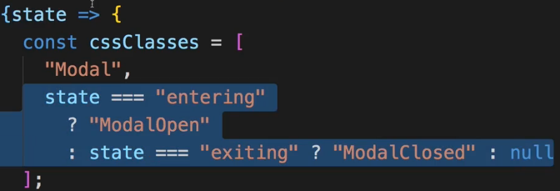  
* And turns out the package we’re using has a special **CSSTransition** component.  
  
* The CSSTransition doesn’t use any function inbetween, instead you just enter the JSX code you want to output.  
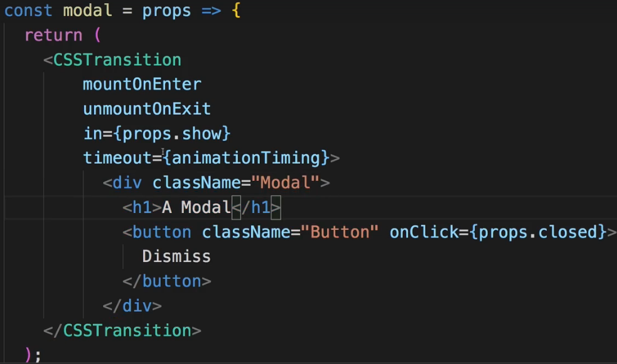  
* Right now, this wouldn’t have any animation.  
* We need to add a special property called `**classNames**`. Here we define which CSS classes should be added to the wrapped element so to this DIV, depending on the state of the transition. It’ll keep the classes we had on the element like “Modal” in our case, but then merge these new classes with that.  
* The CSSTransition component will automatically cycle through a couple of CSS classes and merge them to the DIV here or any element it wraps, depending on the state of the transition.  
* The classes it cycles through are 4: name-enter, name-enter-active, name-exit, name-exit-active.  
=> -enter and -exit will be removed after 1 frame, we can use these classes to do some initialization, like for example set the opacity: 0 at the start of the animation.  
=> -enter-active and -exit-active is when we then play the actual animation. So there we add the `animation` property.  
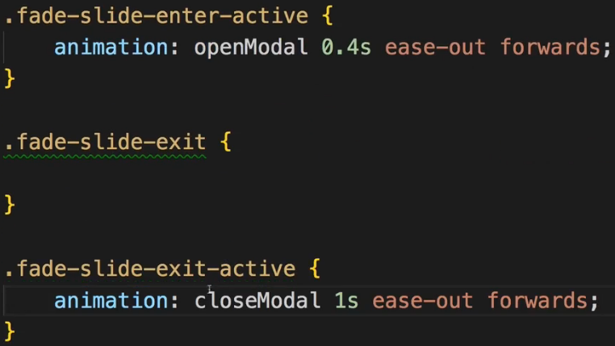  
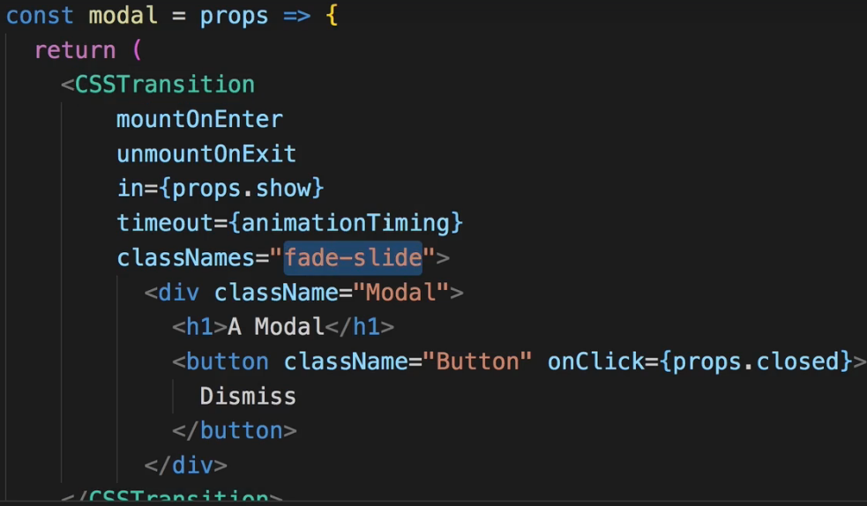  
* So now we’re playing the animations from before again, but now we don’t manually have to assign CSS classes and join them together, instead now we’re taking advantage of the CSSTransition component which moves through these CSS classes, based on our trunk (base class name), automatically.  
* And therefore you often find yourself using CSSTransition, it often is the more convenient component to use since you can control the entire animation in CSS code by simply defining these CSS classes.  
**Customizing CSS Classnames**  
* For some reason you could also want to make sure that you still use .ModalOpen and .ModalClosed, so that you essentially don’t have to define these 4 classes.  
=> For that reason you can not only pass a string with your trunk (base class name), you can also pass a JavaScript object and in this object you can manually define various CSS classes that should be used for the different hooks.  
=> So there you can define: **enter**, **enterActive**, **exit**, **exitActive**, **appear**, **appearActive**. The last 2 you don’t have to define, they also would’ve been added to your trunk. The appear and appearActive are used for the first time something is rendered to the DOM, not when doing it conditionally by rendering it for example upon a button click or not, but if you hard-coded it into the DOM like in our App.js the h1 and the button is - so if it’s always there but if the application loads, that’s of course the first time this gets mounted to the DOM and you could animate this with the appear.   
* If to any of them you don’t want to add anything, you just don’t define it or add an empty string ‘’.  
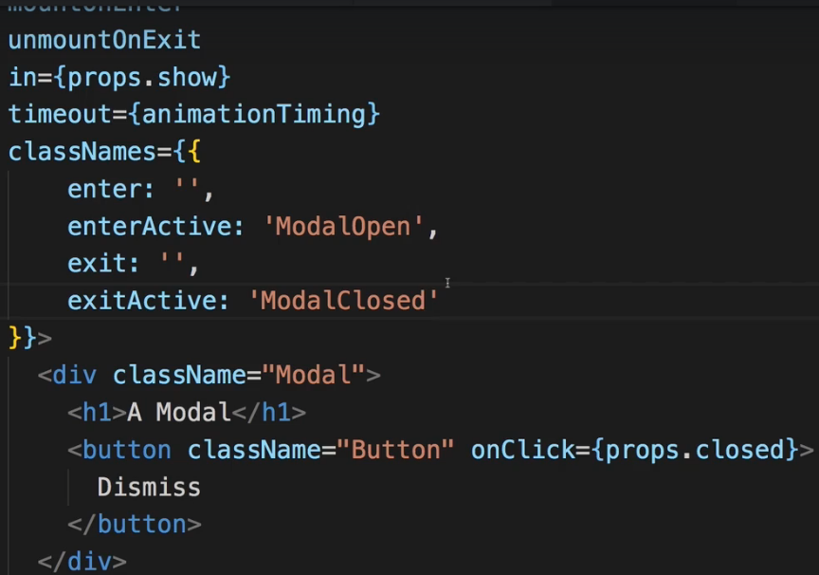  
* Now we got the same animations as before but now we’re using our own CSS classes.  
**Animating Lists**  
* We spent a lot of talking about Transition and CSSTransition because it’s really super important.  
* What, however, about our List? In this List, we’re also of course adding and removing items, and it would be nice if we could animate that too.  
* We can’t do it with Transition and CSSTransition alone though.  
* Instead, we’ll have to use an additional component from that package.  
* It’s called **TransitionGroup**:  
  
* TransitionGroup can be used in places where you output lists. So where you have a dynamic list of elements.  
* We replace the <ul></ul> with it.  
* By default this would render a DIV in its place, so we can define a `component` property there, to still render an ul element so that we work with that but then it’ll replace itself with this ul and still wrap our listItems.  
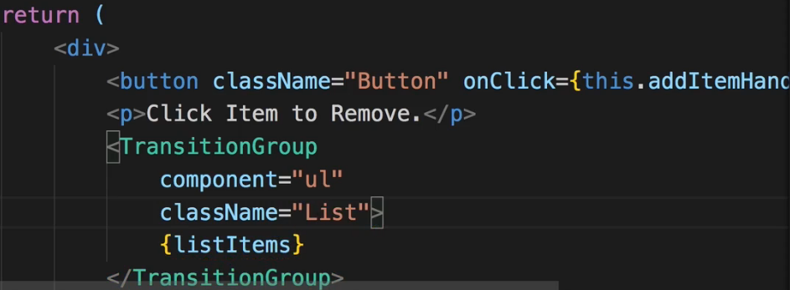  
* Now it still works but we get a couple of warnings.  
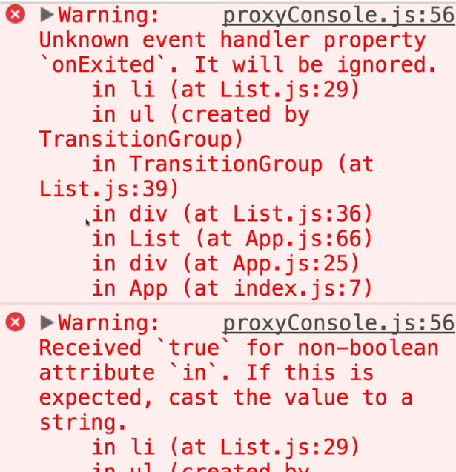 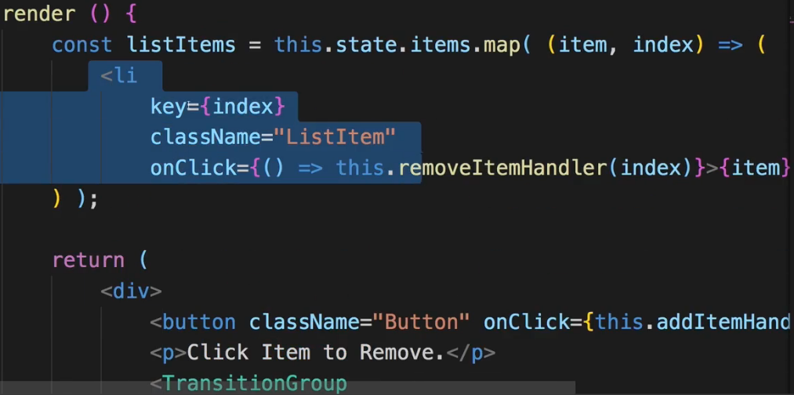  
=> Well, we’re getting all these warnings because right now with our TransitionGroup we’re still wrapping a list of list items.  
* And TransitionGroup can be used for animating lists BUT only in conjunction with the Transition or the CSSTransition component. They then both work as you learned. Now we can use it to wrap our list items.  
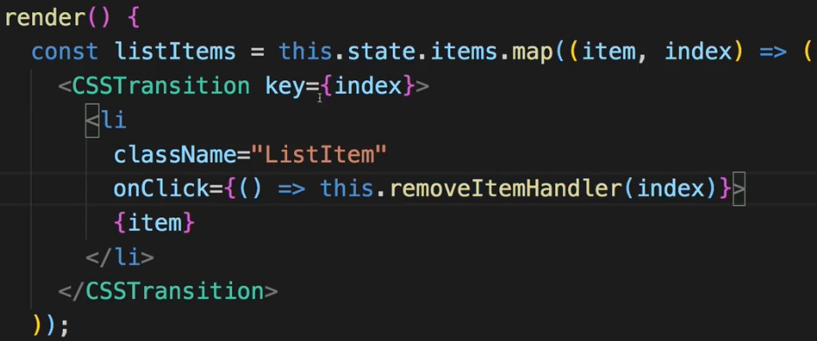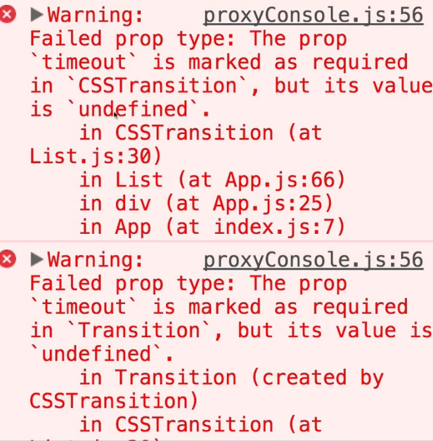  
* Now we get different warnings.  
* And if I click “Add Item”, we also get:  
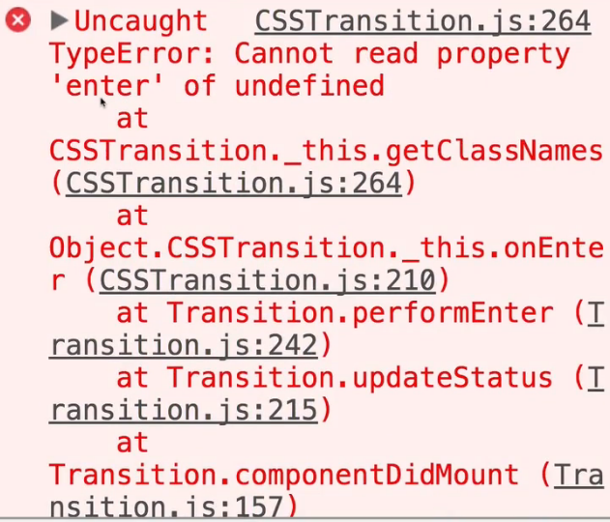 - the enter class it essentially tries to add to the css class.  
* That’s because CSSTransition isn’t configured correctly:  
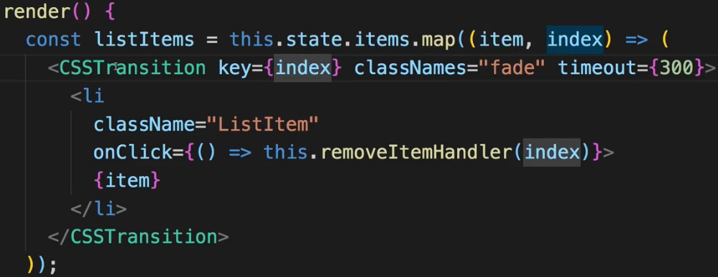  
* Now we can start animating this.  
* Now you might miss the `in` property we used before to control the state of our transition, this special thing about TransitionGroup and essentially the only thing it does is: **it’s able to handle multiple items, it determines whenever 1 element in the list changes - if it’s removed or added, and it’ll then manually set the `in` property on the wrapper Transition or CSSTransition component** so that you don’t have to control the `in` property because you of course can’t do that - you’re having a dynamic list in the end. So with that, the management of the `in` property is the main different.  
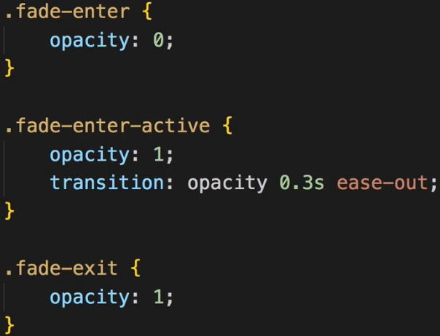  
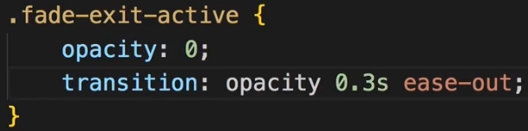  
* Now it’s getting animated, when we remove a list, it animates the wrong one due to the way we manage this list with this key={index} which really is just the index.  
* So the TransitionGroup in the end is just a helper, automatically setting the `in` property on CSSTransition or Transition and then you work with these CSSTransition or Transition components just as you learned it.  
**Alternative Animation Packages**  
* So in this module you learned a lot about **React-Transition-Group**.  
* This package which gives us all these components we used, to animate things in React, especially and most of the time relevant: when we are removing and adding elements to and from the DOM.  
* There are alternatives to this package.  
* 1 popular alternative is **React-Motion**.  
* Now a React-Motion follows a totally different approach. In React-Motion for example you don’t really define manually the time the animation should take, instead, React-Motion tries to emulate real-world physics to figure out the best timing an animation should take and it simply allows you to define END and STARTING states and it tries its best to use these real-world physics to emulate or to interpolate the state inbetween.  
* You can check the DEMO on its GitHub page and check the documentation.  
* It can be tough to get started with React-Motion due to its very unorthodox way of thinking about animations, and some animations are kind of hard to do with it, but it might be awesome for a lot of other cases and might give you this more natural-looking animation look you might want for certain kinds of animations.  
* Another alternative is **React-Move**.   
* You can check its GitHub page or its official web page.  
* React-Move has 2 basic components it exposes to you which allow you to animate single items or groups of items: Animate and NodeGroup and with React-Move you always work with objects, describing the state of an animation. React-Move is heavily influenced by D3.js transitions. Here you do define durations but you then don’t just define styles like opacity and so on, but you can really control way more with that and build more complex animations with it.  
* So this might be especially interesting to you if you have more complex animations.   
* Now again this is a bit more complex library, might also have functionalities you don’t need, so I recommend starting with React-Transition-Group, but if you need more control, React-Move is an alternative you might wanna look into.  
* And finally there is React-Router-Transition.  
* That’s another library I wanna mention, though, there are more libraries than that and you can get a feeling of a new React animation library coming up every week.  
* But React-Router-Transition is a very intresting and special one.  
* It is, as the name suggests, there to allow you to easily create ROUTE transitions, so animations between different routes.  
* It builds up on React-Motion and it basically gives you this AnimatedSwitch component which you use to replace your normal Router Switch with and it’s made to work with React Router v4 or higher. And AnimatedSwitch then does all the same the normal Switch does but it allows you to define atEnter, atLeave, atActive and then a className which is set up like this:  
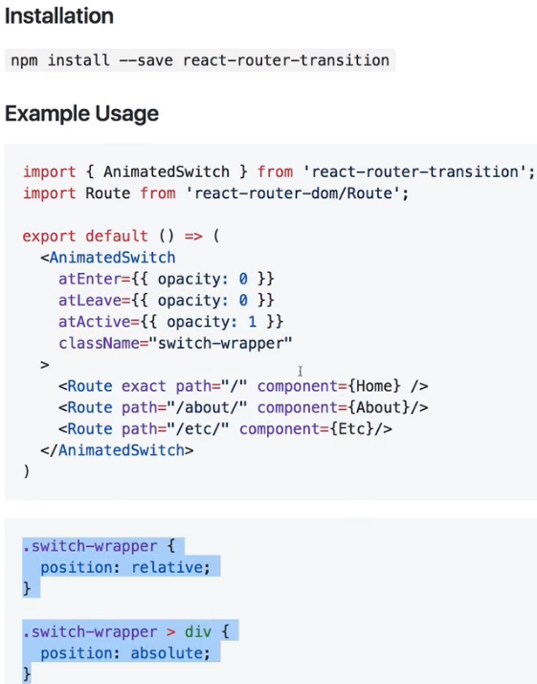  
to allow you to animate the Routing. So to animate the switching of pages.  
* You can dive deeper on this GitHub Repository where you find links to the docs, because animating Route transitions can be very tricky with React-Transition-Group and with the React-Router-Transition package, it’s so much easier and it allows you to really build a nice looking, highly dynamic application and add these Route transitions if you need them.  
**Wrap Up**  
* The key takeaways are that you should always think about CSS animations and transitions. A lot of things can be achieved with just these and even if you fall back to libraries like   
React-Transition-Group, as you saw, behind the scenes you still work a lot with CSS transitions, you just have a JavaScript layer to orchestrate the addition of these different CSS styles.  
* The React-Transition-Group is nice because it gives you a nice little JavaScript layer you can add to your application to orchestrate your CSS animations.  
* You can look at packages like React-Motion if you want a more CSS-independent solution, which still behinds the scenes uses CSS, but which emulates real-world physics and which therefore might give you the look you’re looking for.  
* Animations can be really important at guiding user’s attention and providing a nice User Experience.  
**More on CSS Transitions**: <https://developer.mozilla.org/en-US/docs/Web/CSS/CSS_Transitions/Using_CSS_transitions>   
**More on CSS Animations**: <https://developer.mozilla.org/en-US/docs/Web/CSS/CSS_Animations/Using_CSS_animations>   
**More on ReactTransitionGroup**: <https://github.com/reactjs/react-transition-group>   
**Alternative => React Motion**: <https://github.com/chenglou/react-motion>   
**Alternative => React Move**: <https://github.com/react-tools/react-move>   
**Animating Route Animations**: <https://github.com/maisano/react-router-transition>s